**2.2 Assignment Instructions**

**Scenario**You are a new hire for TechZone, Inc. You are hired as a sales representative and will frequently travel to events around the country. You will need to **share your calendar**, **prepare a folder using an Excel file**, **sort and filter your emails**. When you finish all required tasks using the directions below, submit your final document using the appropriate Submit Assignment button in Canvas.

**Directions:**

**Share a calendar:**

1. Save the attached Excel Travel Expense data file located in Canvas to your student drive, your local computer drive, or to a flash drive. Save carefully so that you know how to locate your saved files.
2. Open your student Outlook App version (downloaded in the Getting Started module)
   1. Prepare to Share your calendar with your instructor. **Note**: Do not send the sharing invitation
   2. Complete a screen print of your sharing invitation and paste below.

**Share a calendar screen print:** 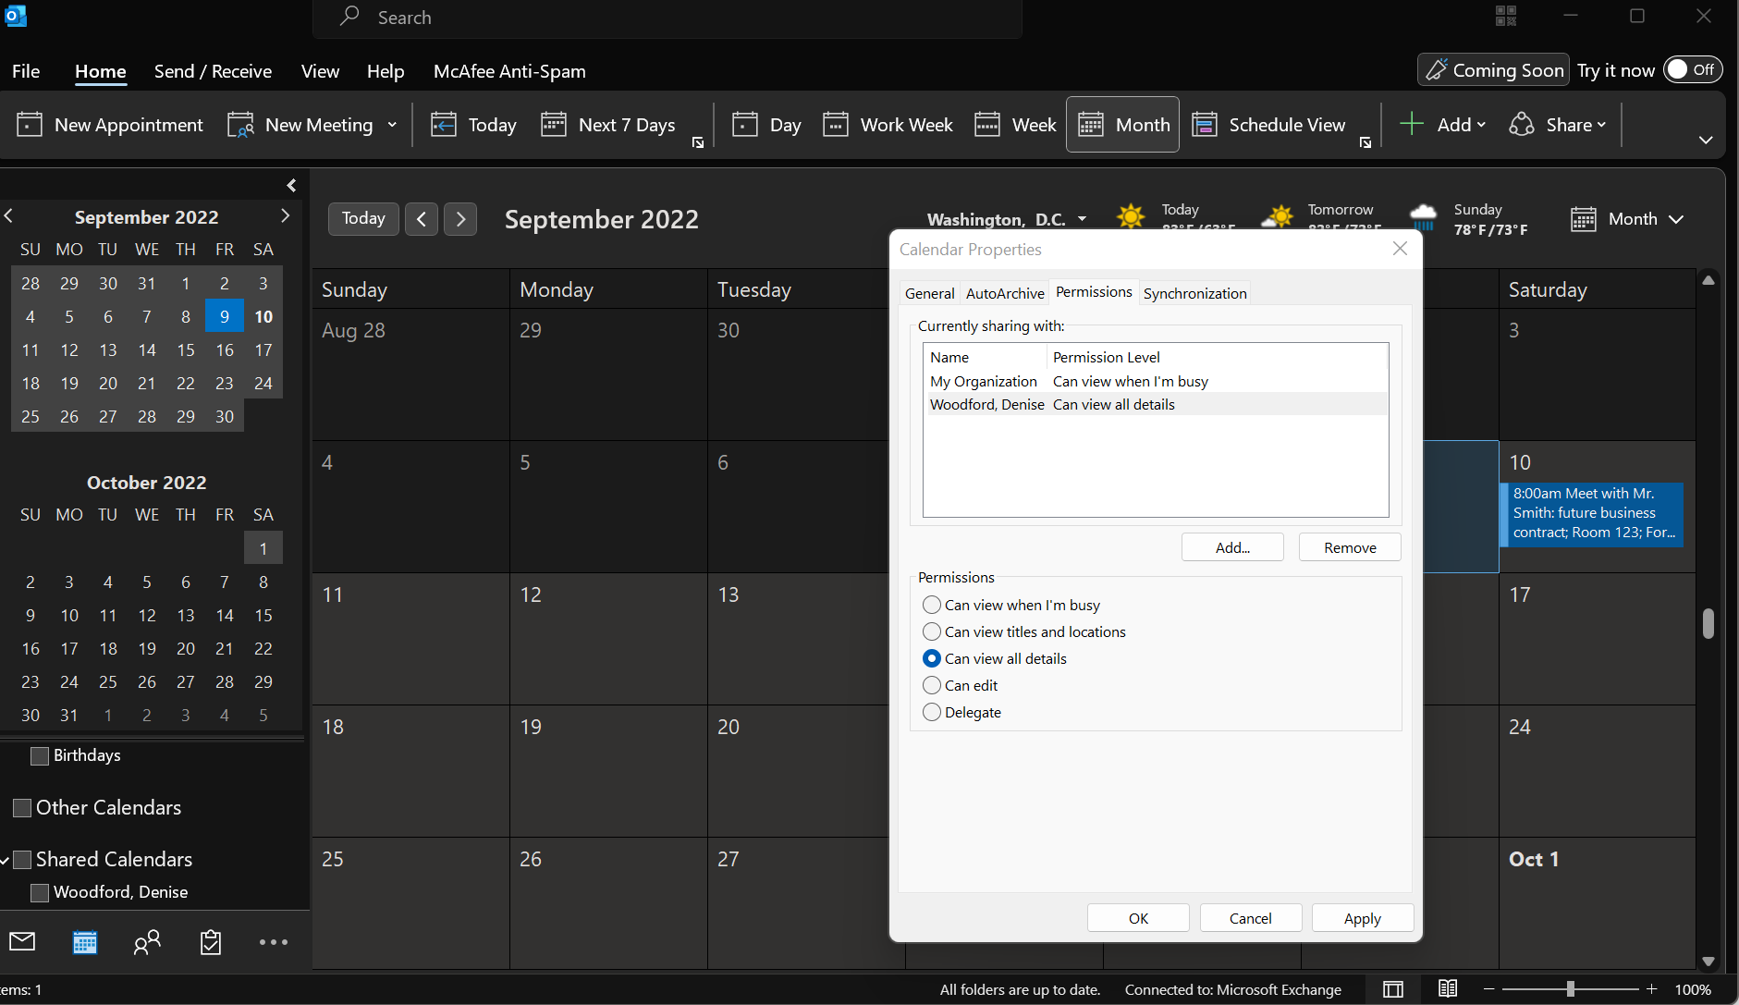

**Prepare a folder using an Excel File:**

1. Prepare a folder in Outlook and name the folder “Travel Expense Reports”.
   1. Send an email to yourself with the Travel Expense data file attached. Then move the Travel Expense data file in this new folder. Complete a screen print of the folder along with its contents and paste below.

**Demonstrate use of sort and filter functions in Outlook Inbox:**

1. Filter your Inbox mail by your Excel instructor name. If you do not have an email from your instructor, sort your inbox by “size” (large to small). Many times, you may have to clean up your Inbox by deleting emails that are very large in size (5 MB-10 MB). To sort your emails by size is one way to find and delete large emails that take up a lot of space within your Outlook account.
   1. Complete a screen print of the filter on your instructor name or the sort of your Inbox email by size from large to small and paste below.

Rename this file ***LastName_FirstName_2.2 Assignment*** and SUBMIT via the Submit Assignment button at the top of the assignment page in canvas. (If working on a mobile device: Submissions tab, Turn In button.)

**Grading Rubric:**

|  |  |  |  |
| --- | --- | --- | --- |
| **Description** | **Skill Performed Correctly** | **Skill Attempted with Errors** | **Skill Not Attempted** |
| Share a calendar | 2 | 1 | 0 |
| Prepare a folder using an Excel File | 4 | 2 | 0 |
| Demonstrate use of sort and filter functions in Outlook Inbox | 4 | 2 | 0 |
| Total | 10 | | |